1. Here is the github link. <https://github.com/Ariyune/Rate-Of-Fuel-Project.git>
2. The SQL statements are as follows: (can also be found as SQL STATEMENTS.txt file attached)

CREATE DATABASE fuelquote;

CREATE TABLE UserCredentials (

usersId int(11) PRIMARY KEY AUTO_INCREMENT NOT NULL,

usersUid varchar(128) NOT NULL,

usersPwd varchar(128) NOT NULL

);

CREATE TABLE ClientInformation (

usersId int(11) PRIMARY KEY,

FullName varchar(128) NOT NULL,

Address1 varchar(128) NOT NULL,

Address2 varchar(128),

City varchar(128) NOT NULL,

State varchar(128) NOT NULL,

ZipCode varchar(128) NOT NULL

);

CREATE TABLE FuelQuote (

usersId int(11),

GallonsRequested int(11) NOT NULL,

DeliveryAddress varchar(128),

DeliveryDate DATE,

SuggestedPriceperGallon FLOAT(11),

TotalAmountDue FLOAT(11)

);

1. The code coverage report again is inside the **html1.rar** file (NOT html.rar). It should look like this upon opening the index.html.

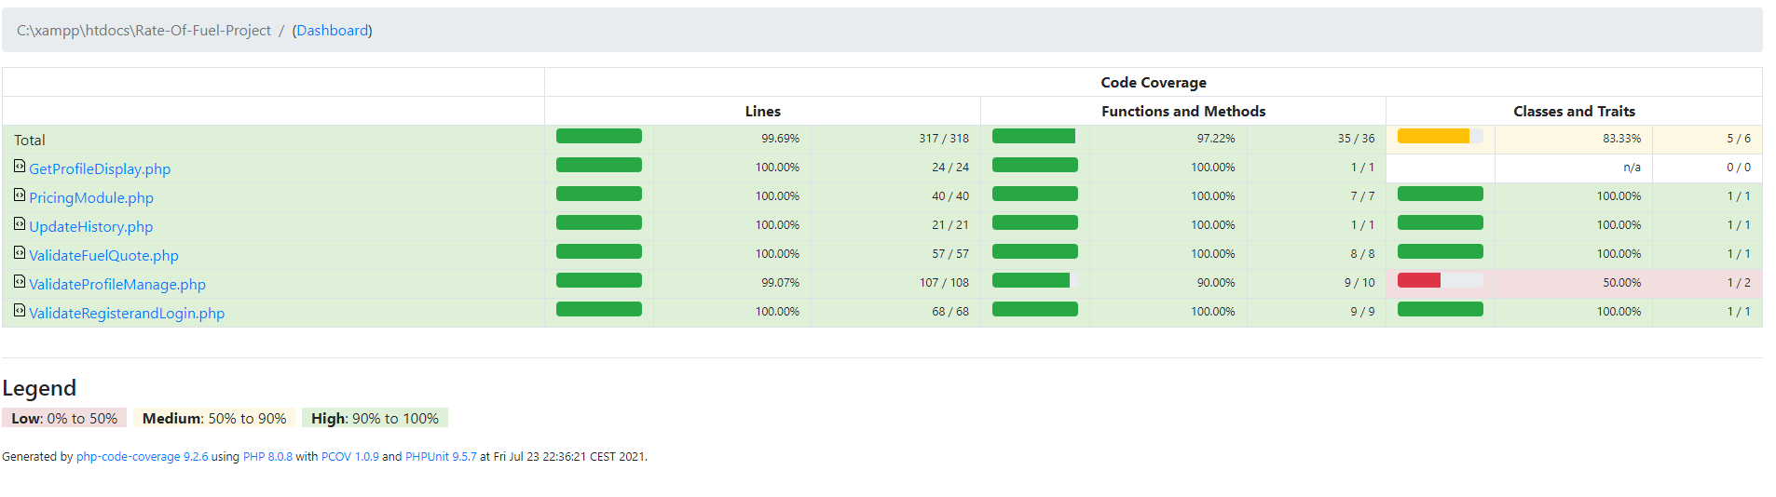

1. Like before, Danny Phan was responsible for the fuel quote and code coverage. Dong Nguyen worked on the login and registration. Carlos worked on the profile management and display pages. Each created and integrated the backend with the databases for their portion.